**Project Design Phase-II**

**Data Flow Diagram & User Stories**

|  |  |
| --- | --- |
| Date | 05 October 2022 |
| Team ID | PNT2022TMID31903 |
| Project Name | Project-Analytics for Hospitals Health-Care Data |
| Maximum Marks | 4 Marks |

**Data Flow Diagrams**:

A Data Flow Diagram (DFD) is a traditional visual representation of the information flows within a system. A neat and clear DFD can depict the right amount of the system requirement graphically. It shows how data enters and leaves the system, what changes the information, and where data is stored.

**ZERO LEVEL DATA FLOW DIAGRAM**

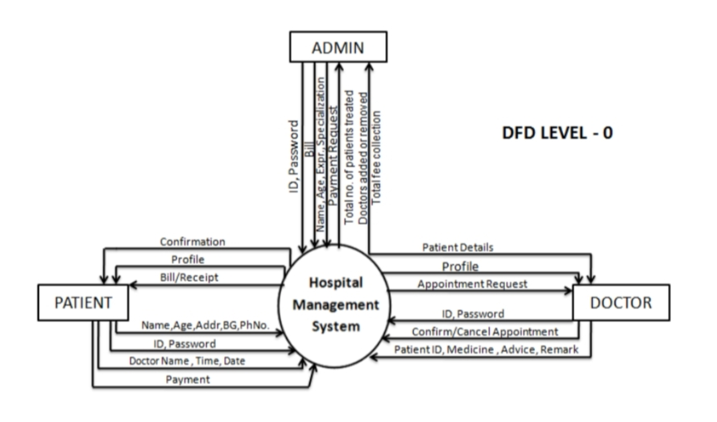

**FIRST LEVEL DATA FLOW DIAGRAM**

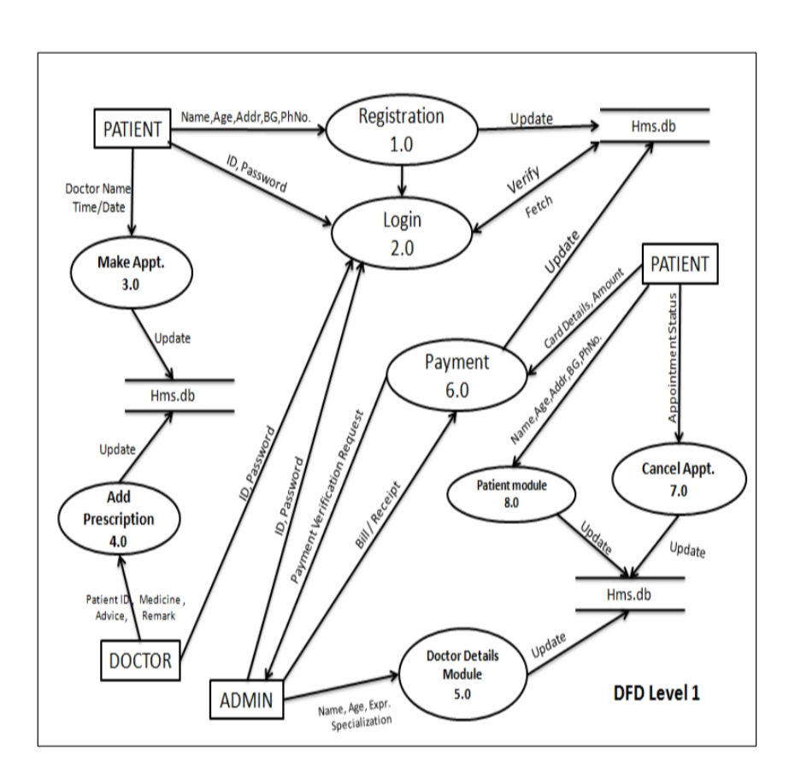

**User Stories**

Use the below template to list all the user stories for the product.

